Experiment-6

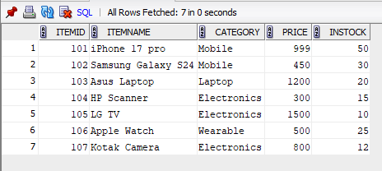

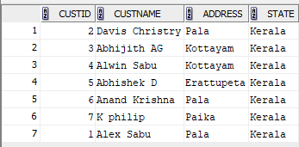

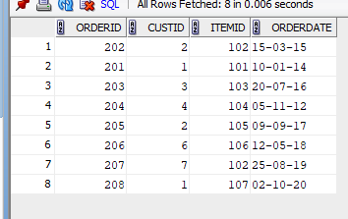

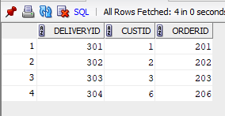

1. SELECT *FROM CUSTOMERS,ORDERS WHERE CUSTOMERS.CUSTID = ORDERS.CUSTID;
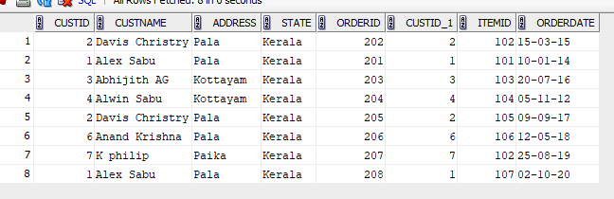

2. SELECT *FROM CUSTOMERS,DELIVERY WHERE CUSTOMERS.CUSTID=DELIVERY.CUSTID;
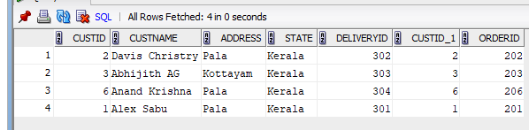

3. select C.CUSTNAME, O.ORDERDATE from CUSTOMERS C join ORDERS O on C.CUSTID = O.CUSTID where C.CUSTNAME like 'J%';
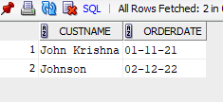

4. SELECT I.ITEMNAME, I.PRICE FROM CUSTOMERS C JOIN ORDERS O ON C.CUSTID = O.CUSTID join ITEMS I on O.ITEMID = I.ITEMID WHERE C.CUSTNAME = 'Mickey';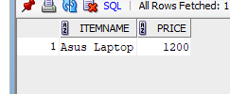

5. SELECT C.* FROM CUSTOMERS C JOIN ORDERS O ON C.CUSTID = O.CUSTID WHERE O.ORDERDATE > DATE '2013-01-31' AND NOT EXISTS ( SELECT 1 FROM DELIVERY D where D.ORDERID = O.ORDERID);
5.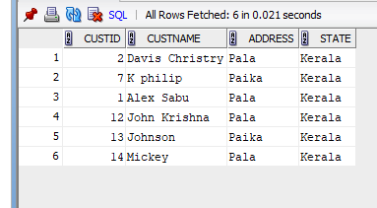

6. select ITEMID from ORDERS UNION SELECT O.ITEMID FROM ORDERS O WHERE O.ORDERID NOT IN ( SELECT D.ORDERID FROM DELIVERY D);

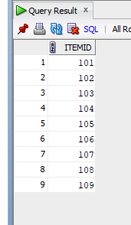

7. SELECT DISTINCT C.CUSTNAME FROM CUSTOMERS C join ORDERS O on C.CUSTID = O.CUSTID JOIN DELIVERY D ON O.ORDERID = D.ORDERID;
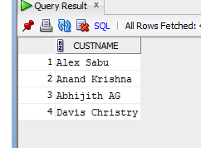
8. SELECT CUSTNAME FROM CUSTOMERS WHERE CUSTID IN (SELECT CUSTID FROM ORDERS) MINUS SELECT C.CUSTNAME FROM CUSTOMERS C join ORDERS O on C.CUSTID = O.CUSTID JOIN DELIVERY D ON O.ORDERID = D.ORDERID;
